Supplemental Figure 1. Secondary exposure metrics—area under the concentration–time curve from 0 to 24 hours (AUC₀–₂₄ₕ) and maximum concentration (Cmax)—are shown for each study drug. Dots represent individual values; horizontal dashed lines indicate the median.

Supplemental Table 1. Final pharmacokinetic parameters.
Parameter (units) | Value (95% CI) ª
 | Pyrazinamide ^{b} | Levofloxacin ^{c} | Linezolid ^{d}
Clearance, CL (L/h) | 4.11 | 6.63 | 3.37
Volume of distribution, V (L) | 44.0 | 96.9 | 37.3
Absorption rate constant, Ka (1/h) | 2.5 | 1.59 | 1.22
Mean transit time, MTT (h) | 0.29 | 1.07 | 0.52
Number of transit compartments, NN (.) | 4.25 | 20 | 5
Bioavailability, F (.) | 1 Fixed | 1 Fixed | 1 Fixed
Effect of serum creatinine of clearance (power exponent) |  | -0.36 | -
Scaling factor for BOV on F, Ka and/or MTT for unobserved doses (-fold) ^{e} | 2.51 | 2.35 | -
Additive error (mg/L) | 0.04 | 0.244 | -
Additive error for unobserved dosing (mg/L) |  |  | 0.05
Proportional error (%) | 8.33 | 7.33 | -
Between subject variability (%)
CL | 18.5 | 22.1 | 37.1
Between occasion variability (%)
Ka | 87.3 | 85.6 | 78.5
MTT | 102 | 45.9 | 56.8
F | 15.8 | 23.7 | 22.0
CSF-to-plasma ratio, Ratio_{CSF-Plasma} (.) | 0.95 (0.91 – 0.98) | 0.55 (0.45-0.67) | 0.38 (0.32-0.47)
Plasma-to-CSF equilibrium half-life, T1/2_{Plasma-CSF} (h) | 0.46 (0.33 -0.60) | 2.2 (1.90-3.60) | 0.8 (0.42-1.56)
Proportional error for CSF (%) | 5.08 (3.7-7.9) | 22.4 (15.9-36.8) | 20.3 (13.8 – 36.5)
Additive error for CSF (mg/L) ^{f} | 0.04 Fixed | 0.02 Fixed | 0.02 Fixed

ª Values in parentheses represent the 95% confidence intervals, estimated using sampling importance resampling (SIR) on the final model. Applied only to CSF parameters, as no plasma pharmacokinetic parameter estimation was performed.
^{b} Pyrazinamide plasma pharmacokinetic parameters correspond to a previously reported model [1]. The reported typical values of clearance and volume refer to an individual with a fat-free mass (FFM) of 44 kg, representative of the typical individual in our cohort and equivalent to the 45 kg FFM individual in the original model cohort.
^{c} Levofloxacin plasma pharmacokinetic parameters correspond to a previously reported model [2]. The reported typical values of clearance and volume refer to an individual with a fat-free mass (FFM) of 44 kg, representative of the typical individual in our cohort and equivalent to the 39 kg FFM individual in the original model cohort.
^{d} Linezolid plasma pharmacokinetic parameters correspond to a previously reported model [3]. The reported typical values of clearance and volume refer to an individual with a total body weight (WT) of 52 kg, representative of the typical individual in our cohort and equivalent to the 56 kg WT individual in the original model cohort.
^{e} The pyrazinamide model included a scaling factor on the between-occasion variability (BOV) of bioavailability and absorption parameters for unobserved doses. The levofloxacin model included scaling on the BOV of bioavailability.
^{f} The estimate of the additive component of the residual unexplained variability did not significantly differ from its lower boundary of 20% of LLOQ, it was consequently fixed to this value.
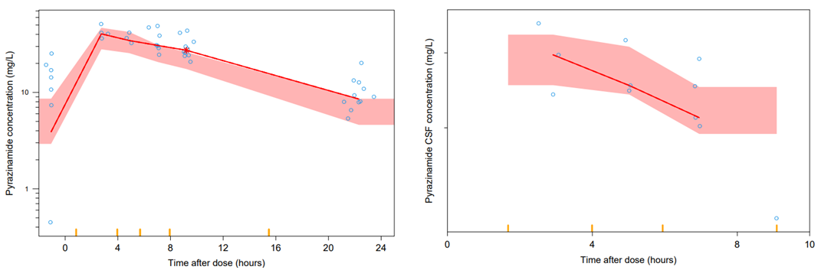
Supplemental Figure 2. Visual predictive check for pyrazinamide plasma and cerebrospinal fluid (CSF) concentrations versus time after dose. The circles represent the original data, the solid lines are the 50th percentiles of the observed data, while the shaded areas represent the corresponding model-predicted 95% confidence intervals.
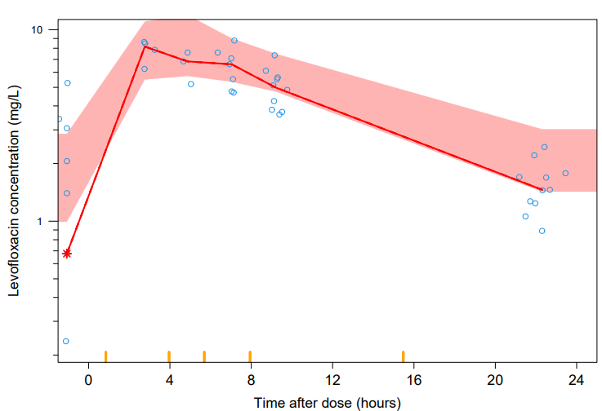
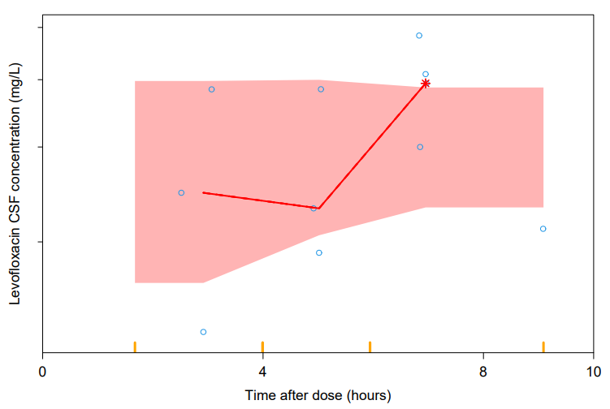
Supplemental Figure 3. Visual predictive check for levofloxacin plasma and cerebrospinal fluid (CSF) concentrations versus time after dose. The circles represent the original data, the solid lines are the 50th percentiles of the observed data, while the shaded areas represent the corresponding model-predicted 95% confidence intervals.
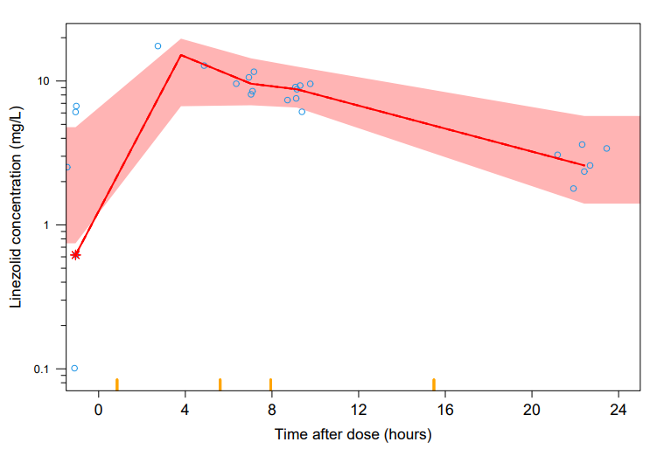
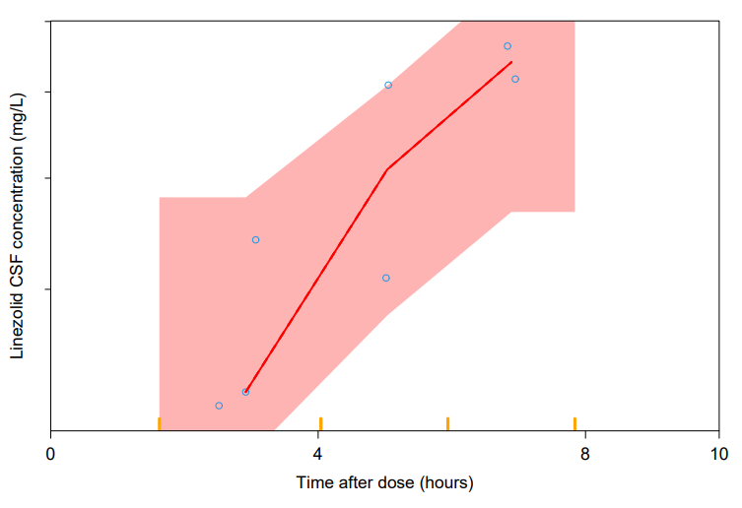
Supplemental Figure 4. Visual predictive check for linezolid plasma and cerebrospinal fluid (CSF) concentrations versus time after dose. The circles represent the original data, the solid lines are the 50th percentiles of the observed data, while the shaded areas represent the corresponding model-predicted 95% confidence intervals.
REFERENCES
1. Calderin JM, Wasserman S, Resendiz-Galvan JE, et al. Population pharmacokinetics of pyrazinamide and isoniazid in plasma and cerebrospinal fluid from South African adults with tuberculous meningitis. Antimicrob Agents Chemother 2025; Available at: https://journals.asm.org/doi/10.1128/aac.00099-25.
2. Sawe S, Tsirizani L, Court R, et al. The effect of pregnancy on the population pharmacokinetics of levofloxacin in South Africans with rifampicin-resistant tuberculosis. Antimicrob Agents Chemother 2025; 69. Available at: https://journals.asm.org/doi/10.1128/aac.01626-24.
3. Abdelwahab MT, Wasserman S, Brust JCM, et al. Linezolid Population Pharmacokinetics in South African Adults with Drug-Resistant Tuberculosis. Antimicrob Agents Chemother 2021; 65:10.1128/aac.01381-21. Available at: https://journals.asm.org/doi/10.1128/AAC.01381-21.

